Fallen Heroes Memorial Dog Tag Flag on display
at Patriot Park

VAU’s Fallen Heroes Memorial, made of 7056 dog tags that create an image of the American flag, will be on
display at Patriot Park Memorial location. The memorial also has 50 gold stars on the flag to honor Gold Star
families nationwide. The flag is built and funded by veterans. It has travelled to 50+ locations nationwide since
2018. All proceeds from its travel go to support Gold Star family organizations and GWOT Memorial Foundations
mission to build a national memorial in Washington, D.C.

On display 4th of July weekend
Friday, July 1st – Tuesday, July 5th 2022
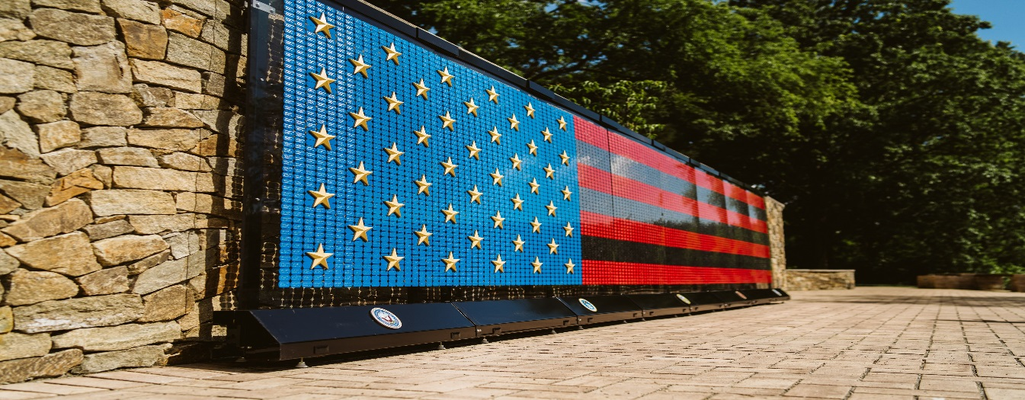

Patriot Park Global War on Terrorism Memorial
6150 Lincoln Highway, Stoystown, PA 15563
Just West of the Flight 93 Entrance

For more information on the Fallen Heroes Memorial and VAU, please visit www.vetsau.com/memorial or on social
media – FB VAU Veterans and Athletes United, and Instagram: @VetsAU

For more information on Patriot Park, please visit www.patriotparkfoundation.org

