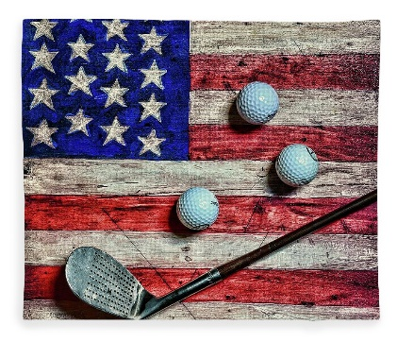
Somerset Country Club
416 Plank Road
Somerset, PA 15501
(814) 445-5200

For Immediate Release

Annual Veterans Golf Event
Somerset, PA --- Somerset County Veterans are planning the annual “Salute to Veterans” golf day to be held Monday, May 22, 2023 at the Somerset Country Club.
Going into the 12th year for this event, the organizers expect another sell-out golf outing to be consistent with past years selling out with 100 participants per each tee time at 8 a.m. and 1:30 p.m. The Somerset Country Club partners with several veterans’ organizations and local businesses to show their appreciation by offering a free day of golf to people from the county who served in the military.
The golf day is free to all veterans. The Somerset County Veterans event organizers thank both past and present sponsors. “Our corporate sponsors, along with veteran and social organizations of Somerset County have really made this event a huge success”, said Barry Fitzgerald, Somerset County Veterans committee member.
The lunch buffet will be open at noon with the program starting at 12:30 p.m. Organizers also anticipate 100 to 150 nongolfers at the free lunch and program, with a guest speaker. “We encourage our local veterans to attend this event,” states committee member, David Koontz. “This has been a wonderful event and we will strive to build on the successful attendance rate.”
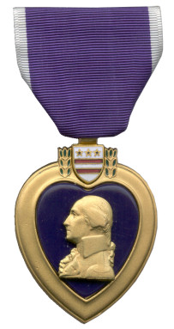
This year’s program will be on the history of the ‘Purple Heart’ and honoring our local recipients. More than a million Purple Hearts have been awarded since General Washington’s Badge of Military Merit was revived in 1932. The unique heart-shaped decoration continues to widely recognized by Americans. It also continues to be prized by all who receive it, probably because the award of a Purple Heart does not depend on any superior’s favor or approval. After all, the Purple Heart is unique as an egalitarian award in what is usually thought of as a nondemocratic, hierarchical military organization, since every man or woman in uniform who sheds blood or receives a qualifying injury while defending the nation receives the Purple Heart regardless of position, rank, status, or popularity. Guest speakers for the 2023 event will be announced at a later date.

For more information about the event, please contact Bill Aldom, 814-241-7707.
Please call Somerset Country Club Pro Shop to reserve tee times after April 1st when pro shop opens. Somerset Country Club Pro Shop – 814-445-2179.

